|  |
| --- |
| **Advanced Web Technology** |
| Coursework 1 |
|  |
| 2008012 |
|  |
| **Jamal** |
| **11/15/2012** |
|  |

# Requirements of the HRM

## Processes Covered

* An Unauthenticated User Search page

Users will be able to search for other users without needing to log into the system. The results will show the name, title, gender and department they are currently working in.

* Login System

A user authentication system that would allows users access to the below features.

* Employee details

Users with the human resources role and relevant permissions will be able to edit other employee’s details, add new employees, edit his details, and delete employees who have left the company. In addition users without needing extra permissions will be able to edit their details.

* Reports ( A custom reporting system)

A custom reporting system will be implemented to allow users to build and save reports for later viewing.

* Departments (Add, edit, delete, add employee, delete employee, add manager, delete manager)

Users with HR role and relevant permissions will be able to do the above processes. In addition department managers will be able to add and remove employees from their respective department.

* Roles ( roles will be defined like (HR, Administrator, User)

Different roles will be assigned to different users. These roles will have a set of permissions that allow users to interact with certain parts of the system. In addition HR roles can directly set permissions to employees.

* Permissions ( Each role and additionally employee will be given a set of permission show restrict and allow access to different areas of the system)

The permissions are the ones that allow access to areas in the system. In addition to permissions being set on pages, permissions will be set per field basis to allow or deny users access to specific fields in each page.

* Users will be able to view their salary details

All users will be able to view their salary history.

## Users

Users are defined by the roles they are given and the permissions they have been associated with.

An admin would have all permissions.

A HRM would have permissions to edit employee data.

Department managers would have permission to add and remove employees.

## User Login

A basic user login system using usernames and passwords will be used to authorize a user. Username and password details will be stored in the database. Once the user is authenticated the user’s role and permission set will be taken from the database. These permissions will be used to allow and deny him access to certain parts of the system.

## Tables required

### Login Tables

This table is required to store user credentials to be used when a user logs into the system. The user’s username and password will be matched to a row in this database. If the row exists and the data matches the user will be allowed into the system.

Mandatory Columns: Username, Password

### Role Table

Role data that will be assigned to each employee will be stored here. At the point where a user is authenticated the role data pertaining to the user is pulled from this table.

Mandatory Columns: RoleID, RoleName

### Permissions Table

Permission table will be used to store whether or not a user is allowed into the page.

Mandatory Columns: PermissionID, PermissionName

### Non functional requirements

Both the models and the controllers will be exposed through a web service and Ajax calls will be made from the views using JavaScript when submitting data and building the model. To ensure the validity of this system a token authentication for the web services will have to be implemented

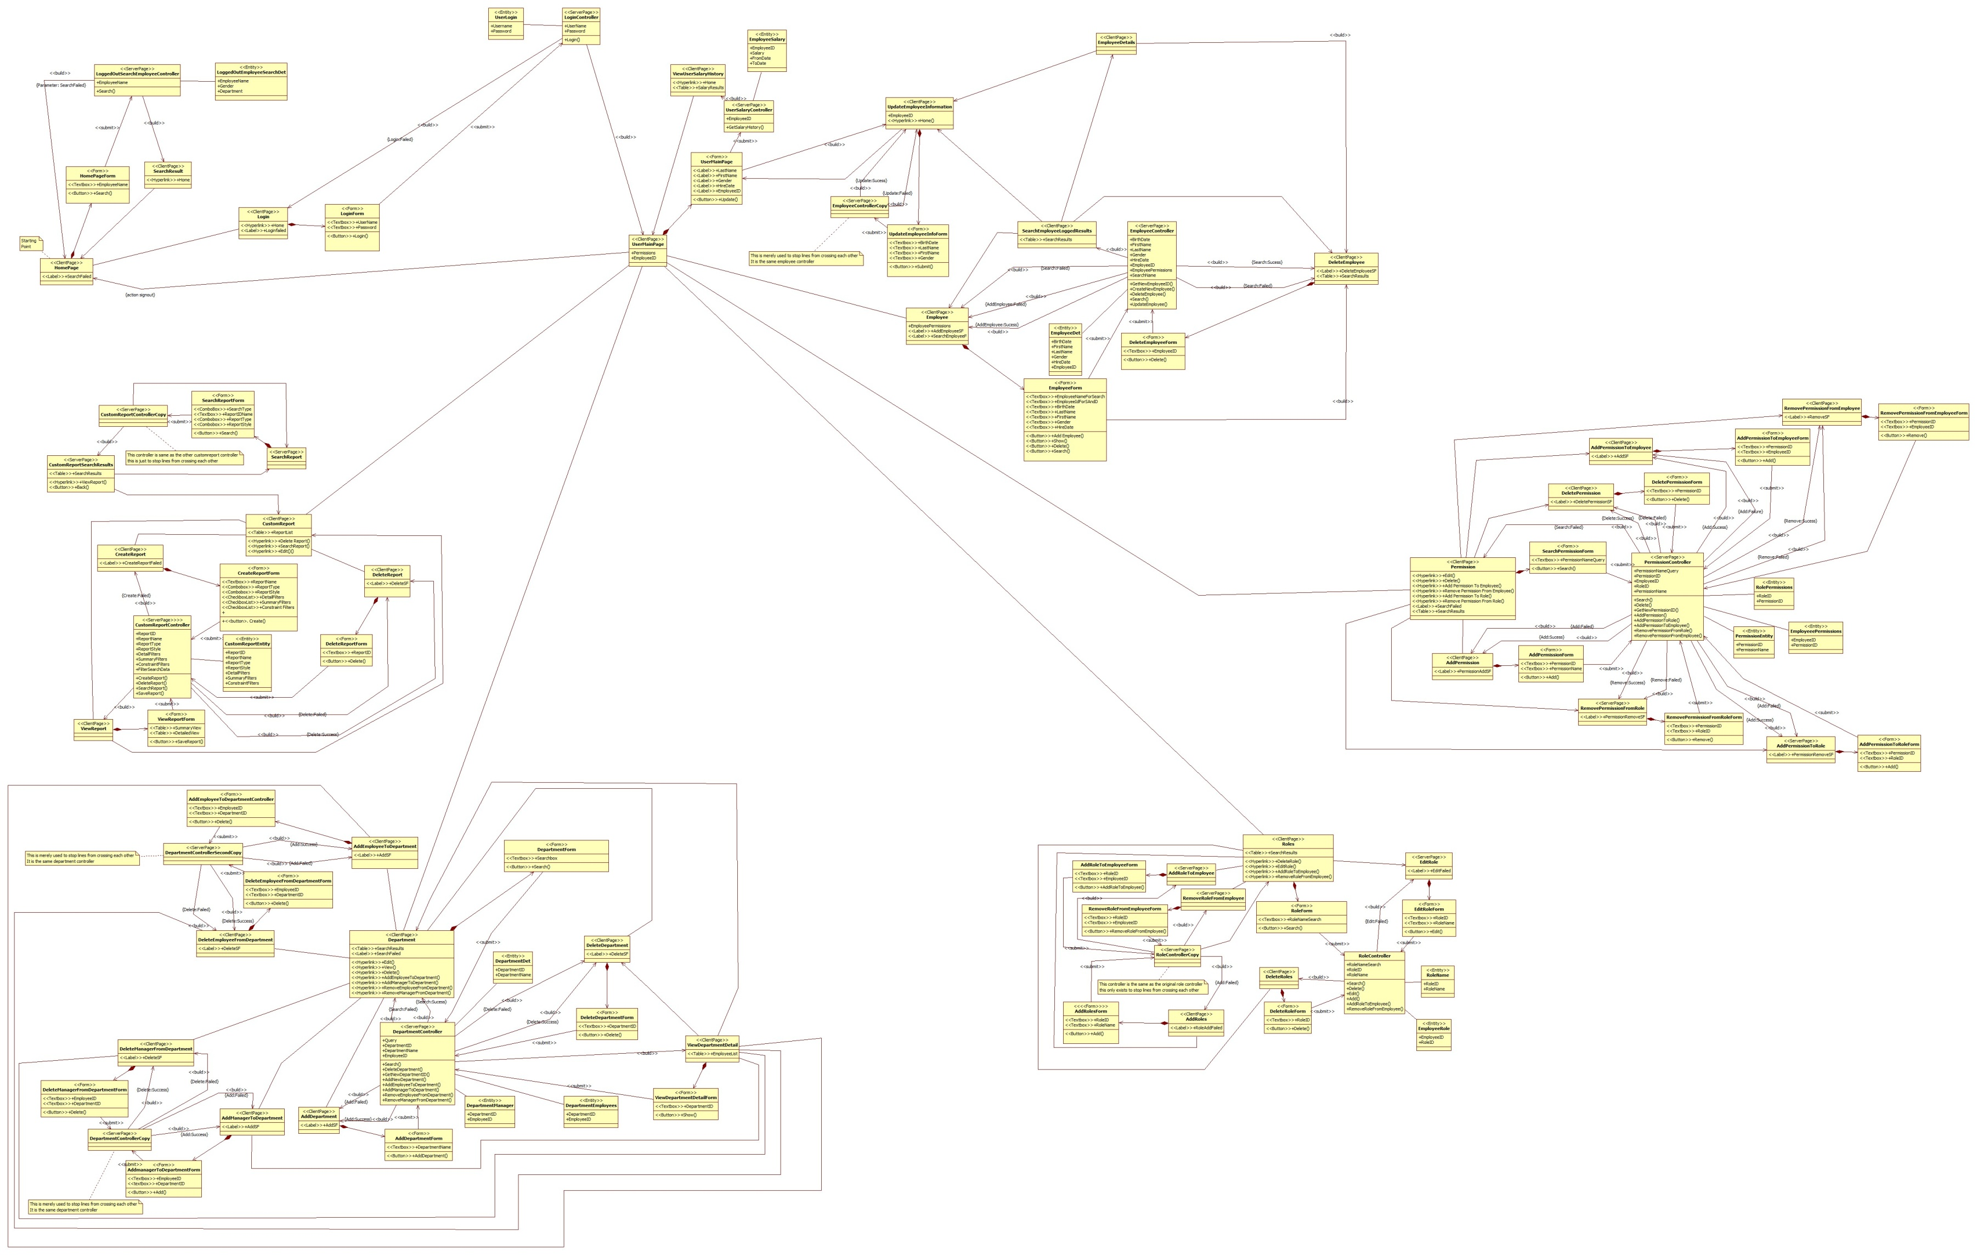

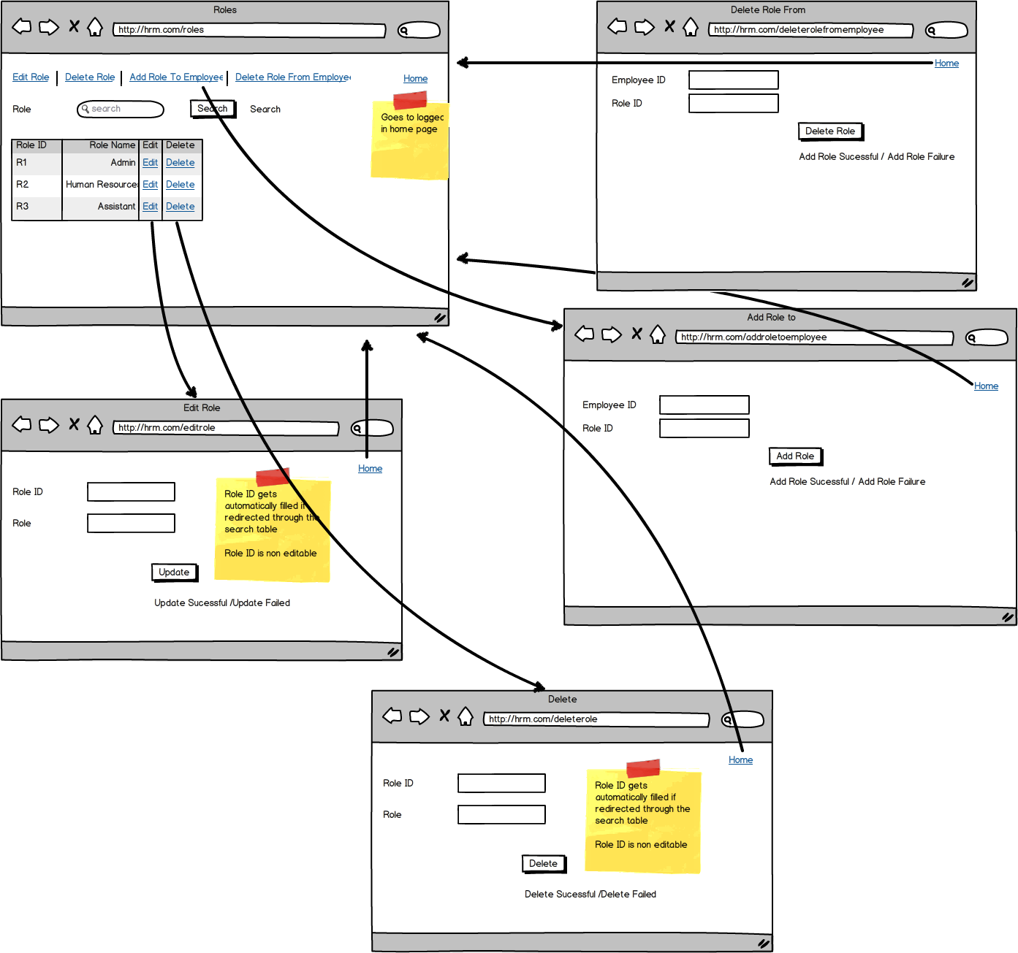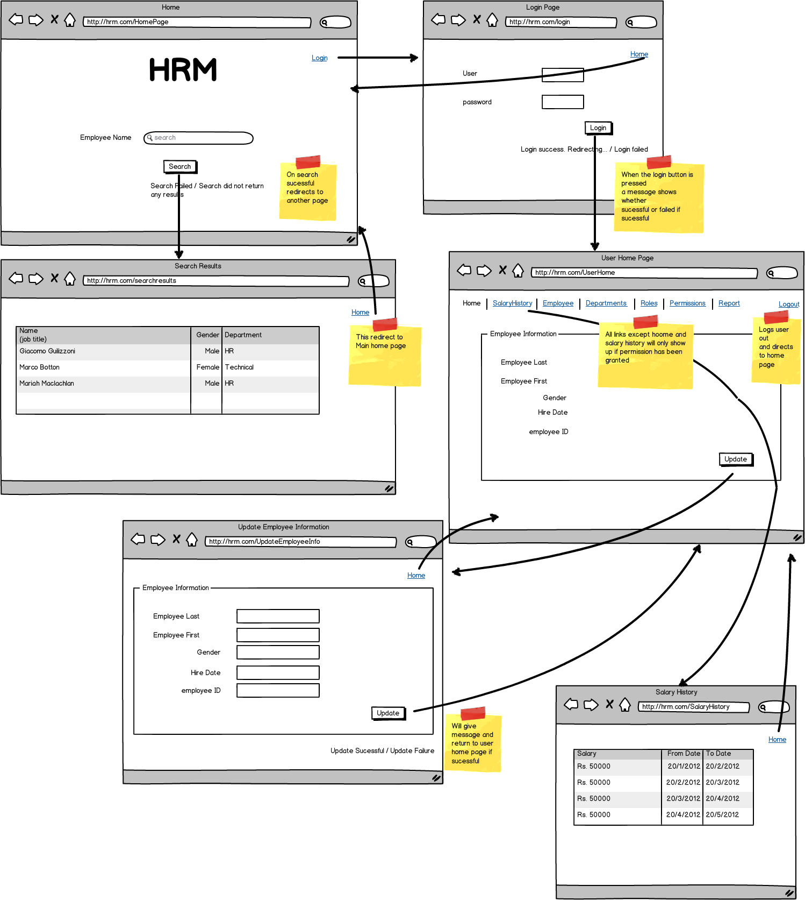

Roles area - figure 2

Home page area – figure 1

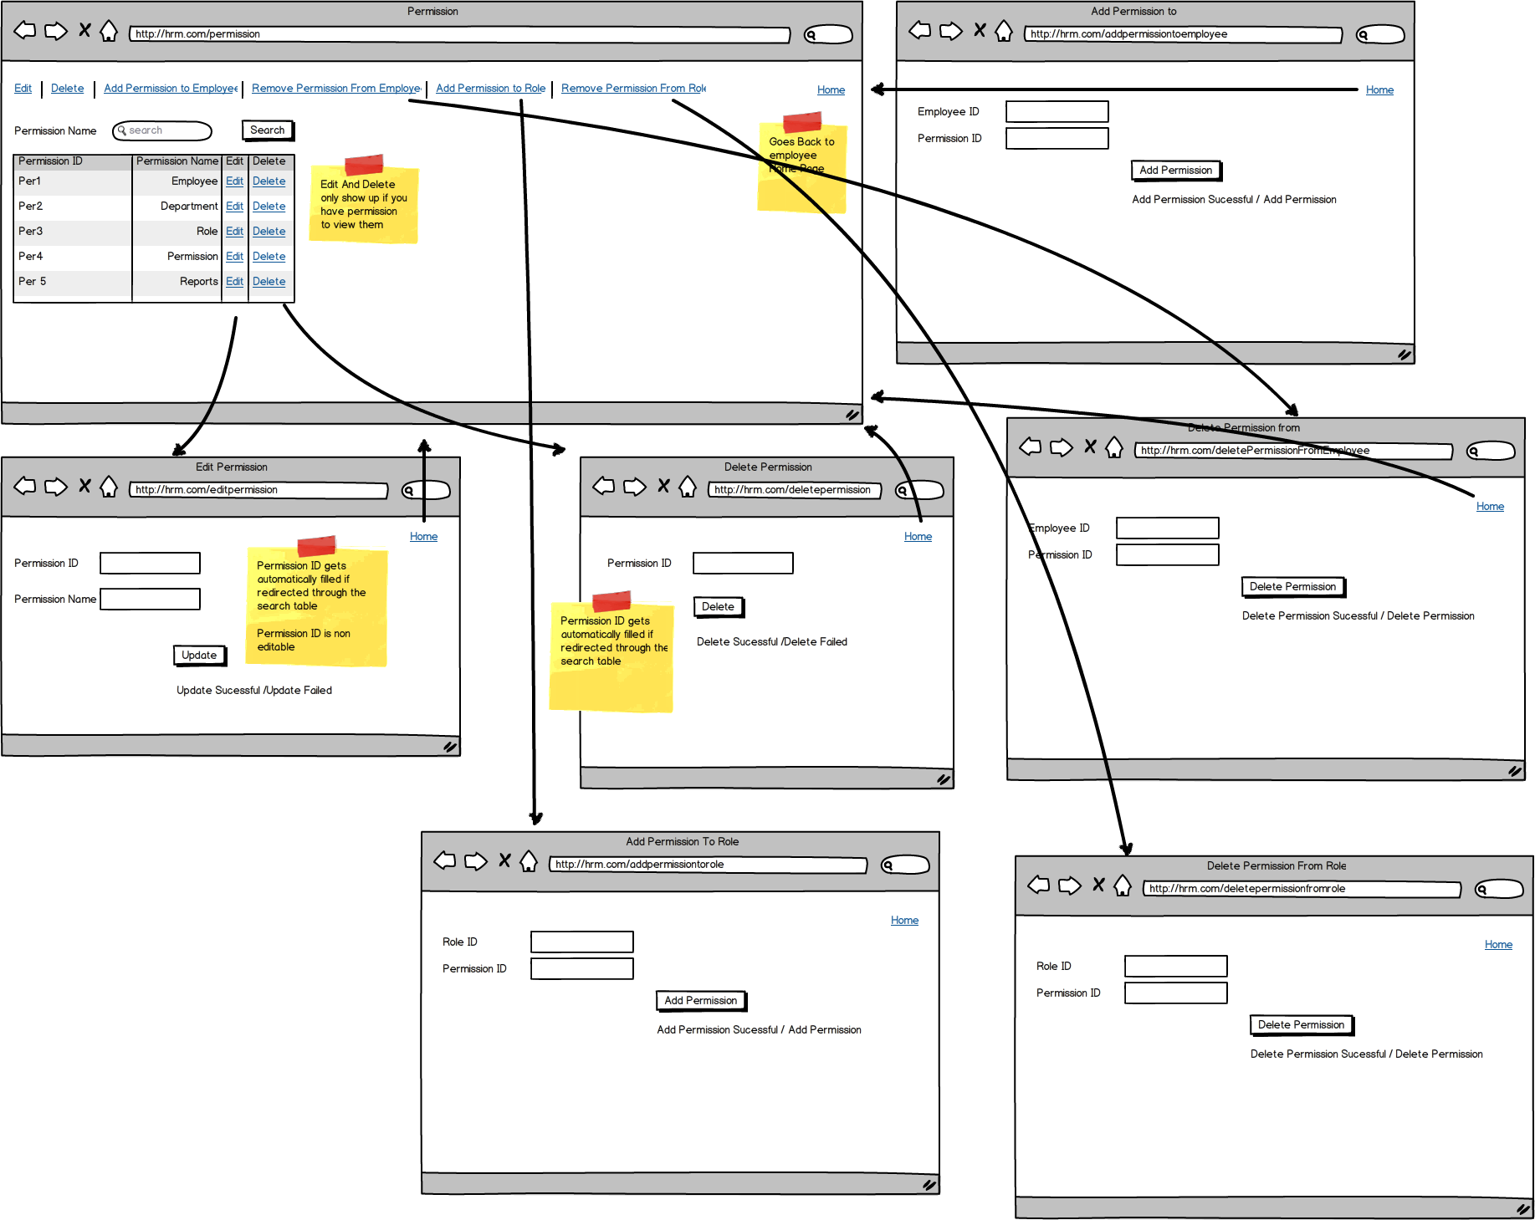

Permission area – figure 3

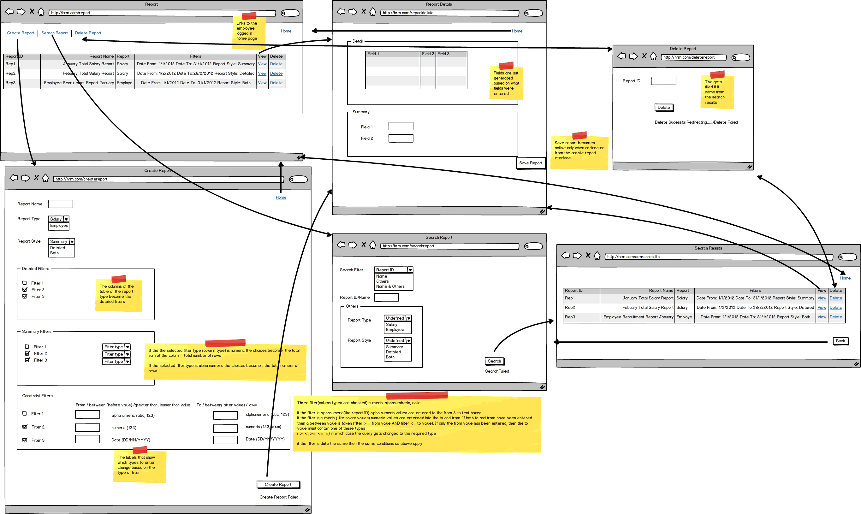

Custom Report area – figure 4

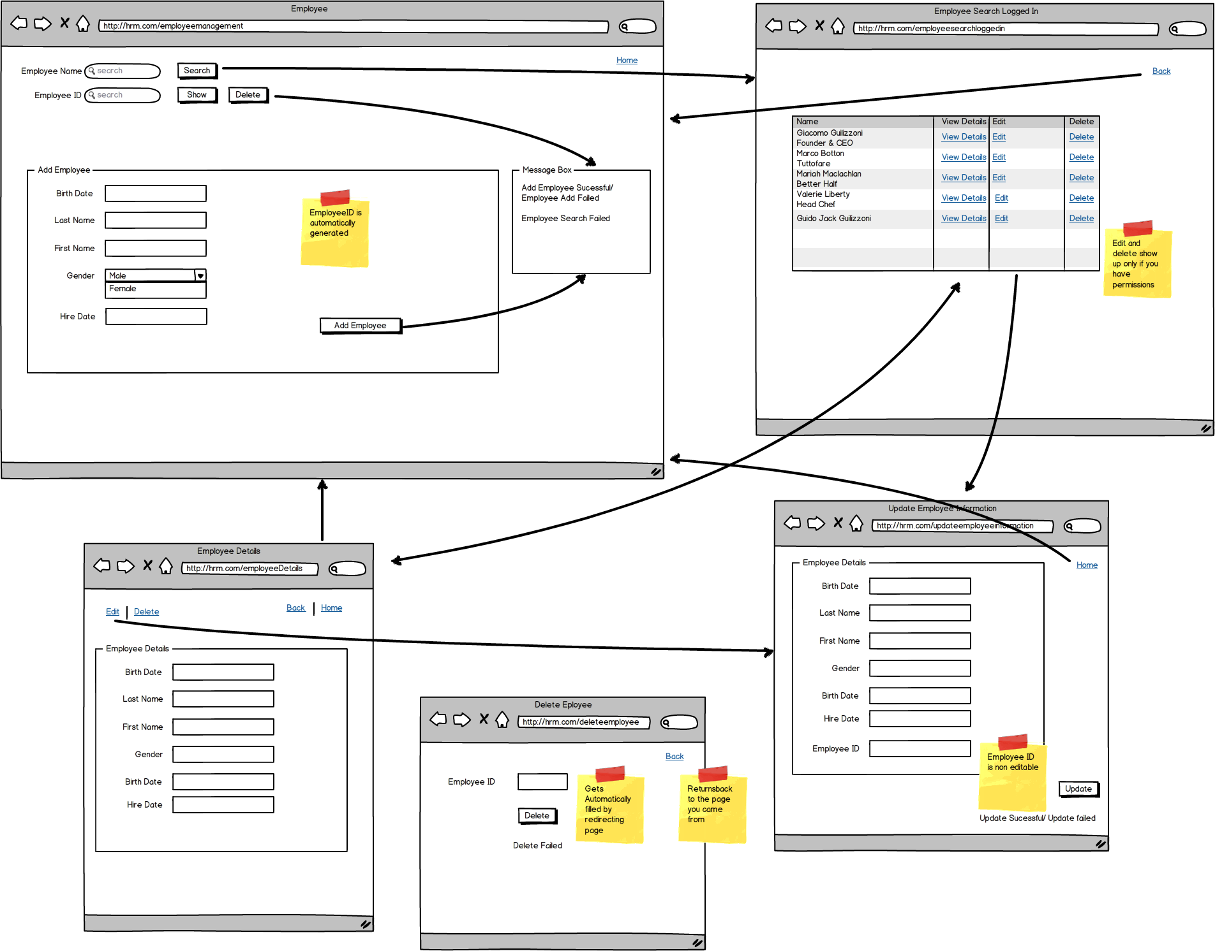

Employee Area – figure 5

# Class diagram

The class diagram has been divided into 6 specific areas.

* Unauthenticated search & Login
* Employee
* Role
* Permission
* Department
* Custom Report

In addition the salary history report area is joined into the employee area

# Mockups

The mockups area divided into 5 specific areas

Figure 1 – Home

Figure 2 – Roles

Figure 3 – Permissions

Figure 4 – Custom report

Figure 5 – Employee

Each figure shows mockups relevant to the said area

# User Authentication

Start

Insert Username and Password

Get Username and password details from the database

If entered username and entered password match database rows

Output Login failed

Redirect to user home page

End